

**STUDENT GUIDE TO**

**EXAMS**

**SUMMER 2023**

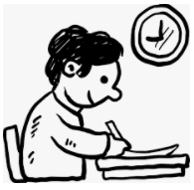

**EXAMS OFFICER’S**

**STATEMENT**

Your GCSE Exams are rapidly approaching. This booklet is designed to offer you help and advice in preparation for these Exams. This booklet also states the rules and regulations of the exam boards that you must adhere to.

Please read through this booklet to ensure that you are familiar with what is expected of you.

May I take this opportunity to wish you well in your forthcoming examinations. Be the best that you can be!

Mrs Glendinning

Exams Officer



**RULES & REGULATIONS**

**YOU MUST:**

1. Be on time for your exams.

* Morning exams begin between 9am and 9.30am.
* Afternoon exams begin between 1pm and 1.30pm.

Make sure you check your individual timetable for your exam start times.

If you are late, your work may not be accepted by the exam boards.

**2.** Always listen to the invigilator and always follow their instruction.

**3.** Ensure that allMobile Phones, Smart Watches, IPods, MP3 players etc are switched off and either stored in your coat/bag at the back of your row or handed in to an Invigilator.

**4.** Remove **ALL** wrist watches as they are classed as unauthorised items and so should not be worn. Please ensure they are also handed in.

**5.** Leave any notes in your coat/bag or hand into an invigilator.

Possession of unauthorised materials is breaking the rules, even if you do not intend to use them!

|  |  |
| --- | --- |
| **BE PREPARED FOR YOUR EXAMS**  **Equipment;** | **j0232723** |

* Get together **ALL** the equipment you may need the night before: two pen’s – black ink only, a pencil, ruler, eraser, compass, protractor. **No correction fluid/tape or gel pens** are to be used in the exam and no highlighters should be used in your answers.
* All this equipment must be stored in a clear, plastic bag or case.
* For certain exams you may require a calculator. Check in which exams you can use them with your teacher and ensure it is suitable as per the calculator rules at the back of the booklet.
* No other material will be allowed and so must be left in your bag at the back of the room.
* Remember to go to the toilet **before** the exam starts, unless you have a proven medical need/toilet pass you will not be able to go to the toilet during the examination.
* Arrive at your assembly area 20 minutes before the start of the exam.

Your final examination timetable will give you all the details you will need: dates, starting and finishing times, seat no. etc. It is your responsibility to look after this timetable. Make sure you keep it somewhere safe!

**DURING THE EXAMINATION**

* Check that you have the right question paper in front of you – check the Subject, Date, Unit and Tier are correct.
* Read the instructions carefully on the front of the question paper/and or on the answer booklet, so you understand what you need to do.

Fill in all the information on the front of the question paper **when told to do so** but **do not** open the exam paper until you have been instructed the exam has begun.

**Tell the Invigilators AT ONCE**

**» If you think you have not been given the correct question paper.**

**» If any of the materials listed on the front of the paper are missing.**

**» If the paper is incomplete or badly printed.**

**If a page is meant to be blank, it will say so!**

* Write clearly and write only in the designated sections of the exam paper only.

Don’t rush. Pace yourself and allow the appropriate time for each question, your answers should be long enough to fit the marks on offer.

Show all your working out/rough work. Neatly cross it through when you’ve finished, but leave it legible. Hand it in with the rest of your answers.

Do not write any inappropriate or offensive material on your exam paper as these may be disqualified by the exam boards.

Leave yourself 5-10 minutes at the end to read through and check all your answers. Boring though this may be, it is very important. You will often find mistakes/omissions and can put them right. It could mean the difference between a Grade 5 and a Grade 4!

* **During the exam, put your hand up if:**

» You need more paper

» You feel ill

» You have a problem and don’t know what to do.

You must not ask for, and will not be given, any help with or explanation of the questions – this is part of the exam.

* **At the end of the exam stop writing when you are told to do so.**

Make sure your Name, Exam number and Centre number are on **all** pieces of paper you hand in. Place any loose additional answer sheets inside your answer booklet, but double check you have added **all** your candidate information to each additional sheet.

* **Exam conditions DO NOT end until you have left the room.**

Don’t be tempted to talk/turn around/communicate in any way with other students. Your paper could still be cancelled!

* **You must not leave the exam room until you are told to do so.**

Once you have been dismissed, collect your belongings and leave the room quickly and in silence. REMEMBER – others may still be sitting their exam in the room.

* **Do not take any exam stationery from the exam room.**

This includes question papers, answer booklets, rough work or any other material provided for the exam.

**YOU MUST NOT:**

**1. Become involved in any unfair or dishonest practice in any part of the exam.**

If you try to cheat or break the rules in any way, this will be reported to the exam board and it may mean being disqualified from all your exams – not just the one you were caught in.

**2. Talk to, communicate with or disturb other students in any way once you have entered the exam room.**

If you do so, the same may happen as in **No1**.

**3. Take to your seat any unauthorised material – for example:**

* Bags, Coats etc. (put them at the back of the room)
* Notes
* Ordinary pencil cases
* Calculator cases with formulae or instruction leaflets.
* Mobile phones, Smart watches, Wrist watches, MP3 Players or IPod’s or any other Electronic Devices.

**4.** **Use a dictionary or computer spell checker unless you are told otherwise**.

**5. Impersonate another candidate**

This is a criminal offence and is dealt with by the police. You may be prosecuted in a court of law.

**6.** **Leave the examination room unaccompanied by an invigilator before the exam has finished** - you **will not** be able to return.

**Candidates have been disqualified from their exam in previous years due to their behaviour and having unauthorised material in their possession.**

**YOU HAVE BEEN WARNED!**

|  |  |
| --- | --- |
| **WHAT TO DO IF YOU ARE ILL ON THE DAY OF AN EXAM** |  |

* If you are ill and are unable to attend an exam it is vital you phone the school first thing in the morning (**01706 647761**) to inform us.
* You must also obtain a note from your doctor detailing the reason for non-attendance. There is the possibility of submitting a Drs Note to the Exam Boards to ask for special consideration. The Board looks at this in conjunction with other exam marks for the student in that particular subject, along with coursework marks and mock exam marks. This will **sometimes** then enable them to adjust the mark and grade accordingly, **although there is no guarantee that this will happen.**
* If you are feeling unwell, but still able to travel, we suggest you come to the exam and we can assess the situation then. **In most cases it is better to take the exam if you can.**
* If in doubt – **PHONE THE SCHOOL**
* If you do not attend an exam without a valid reason, it is possible that you will be charged for that exam. Make sure we have **your mobile phone number** in case we need to contact you.

**Lateness**

* Please always be on time for your exams. Depending on how late you are, the exam boards would have to be informed and they may not accept your paper. However, if you are unavoidably running late please get to school as soon as possible and always inform school that you are on the way and why you are late.

**EXAM CHECK LIST**

|  |  |
| --- | --- |
| j0342967 | Aim to arrive at school 20 minutes prior to the start of an exam AT THE LATEST. It is much better to leave yourself plenty of time in case of problems with the journey. |
| MC900290903[1] | When taking exams, bags, coats and mobile phones etc should be left in the designated area. Because of this, it is recommended that you do not bring valuables with you to the exam. |
| MC900439798[1] | Phones – **Students must not have mobiles phones in their possession**. If a device is found on you **either turned on or off,** the exam boards will be notified and this will more than likely lead to a total loss of marks and even possible disqualification.  Smart watches and **ANY other wrist** **watches** are forbidden in exams and they must be handed in or stored in your bag. If one is found on you, the exam boards will be notified and as above a total loss of marks is a likely outcome and even possible disqualification. |
| MC900433863[1] | Revision Notes, MP3 players etc should also not be in your possession – they should be stored in your bag or handed in as you enter the exam room also. |

|  |  |
| --- | --- |
| j0305509 | You should bring with you the correct equipment needed to do your exams as these will not necessarily be provided in the exam room. Only clear pencil cases are allowed on your desk, any others should be left in your bag. Black ink pens only, **do not use gel pens.** |
| MC900199349[1] | In an exam where you have the use of a calculator; please ensure the case/cover of your calculator does not have any printed formulae or instructions **and** that you have cleared anything stored in the memory. Place any case/covers without formulae/instructions under your desk. |
| Sshh! | There is absolutely **NO** talking or communication between students once you enter the exam room. If you have any questions, you should raise your hand and an Invigilator will come to you. |
| j0232986 | You should wear your **full uniform** for all your exams. |
| MC900264396[1] | No food is allowed in the exam hall. If you have a special requirement – please see the Exams Officer before the exams. |
| **MC900347073[1]** | **Water** bottles **only** are allowed in the exam hall. These should be **clear** bottles with all labels removed and a spill-proof cap. |

MC900078711[1]**Revision Tips & Methods**

1. **Come equipped** – If a plumber turns up to mend my radiator without tools, I know they are not going to do a good job! The same applies to revision. Basics are – stationary, calculator, flash cards, highlighters, post-it notes, pad of paper, revision guides, past papers, water bottle, healthy snacks.
2. **Have a space to revise** – Most people work best if they have a comfortable and suitable working environment. Use a quiet space with no distractions, ensure all your equipment is there and when you sit there it is your place of work.
3. **Flight mode** – For the periods you are revising turn your phone to flight mode! It may seem hard at first but once you have done it 3 or 4 times it will become normal and soon become a habit. You will also soon realise you are not missing out on much!
4. **Nothing is achieved without a plan** – Things rarely happen by chance, there has to be a plan in place to ensure it happens and the same is true of revision. Create a revision timetable and keep a copy in your study area and give a copy to your parent/carer to put on display too. You can then tick off as you go along so you can both see the time you have put in.
5. **Know what you need to know** – Ensure you have links to all the specifications of the examinations you are taking. Your teacher can help you to find these. Use them as a checklist to see exactly what it is you should know for your exams.
6. **Practice, Practice, Practice** – Past or practice papers. Get in to a routine of completing the papers in timed, exam conditions. Highlighting areas or topics that need extra revision. Spend the following session revising these areas or ask your teacher to go over it again.
7. **Flash cards** – You can buy pre-filled cards or make your own and they can be used in conjunction with past papers and revision questions. Once you have identified an area that needs more work use the cards to memorise and learn the specific area.
8. MC900078711[1]**Spaced Learning** – Don’t revise all your topics in one go (cramming), it just doesn’t stay in your head. You should revise ‘chunks’ of topics for small amounts of time (15 mins) and then move onto another ‘chunk’ from a different topic. This will improve your memory!
9. **Interleaving** – Mix up the topics and subjects you do on your revision timetable, spending a long time on one thing often gives us the impression that we have mastered it but upon returning to it, we have forgotten it. Interleaving means returning to topics and subjects more often, increasing the chances of it “sticking”.
10. **The Cornell Method –** The Cornell method of taking notes is an effective way of revising. It is a great method to get you to ‘think’ about your revision. Simply split your page into 3 sections as shown in the diagram below:

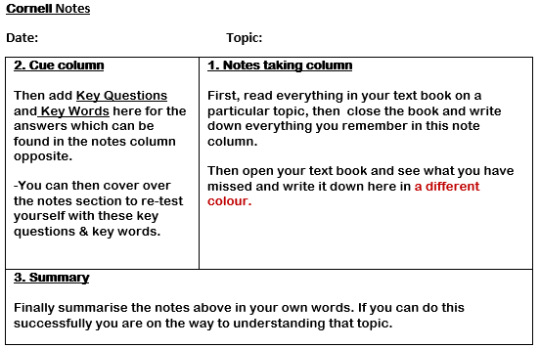

**11.Team work** – Revision doesn’t have to be a sole pursuit! It is a great idea to break up study days by visiting a friend’s house and a group of you working together, testing each other, and marking each other’s work.

**And Finally, ‘do the hard work’.** To remember and progress you need to be pushing yourself and putting in the hard work. Imagine training for a marathon, it takes hard work and effort, this should be the same when preparing for your examinations!

**FREQUENTLY ASKED QUESTIONS**

**Q. What do I do if there is a clash on my timetable?**

It will be indicated on the timetable if there is a clash of exams, with details of which exam to sit first and the start time of the following exam. If you have any questions then consult the Exams Officer immediately.

**Q. What do I do if I think I have the wrong paper?**

Invigilators will ask you to check before the exam starts. If you think something is wrong put your hand up and tell an Invigilator immediately as mistakes cannot be rectified after the exam.

**Q. If I’m late can I still sit the exam?**

This depends on how late you are. You should get to school as quickly as possible and report to reception. A member of staff will escort you to the exam room. You **must not enter** the exam room without permission once an exam has started. Depending on the length of the exam and how late you are school may have to inform the exam board and it is possible that they may not accept your work.

**Q. If I miss the examination can I take it another day?**

No. Timetables are regulated by the exam boards and you must attend on the given dates and times.

**AFTER THE EXAMS HAVE ENDED**

**How do I find out my results?**

There are two ways of doing this:

* Results will be available from school on **Thursday 24th August, 2023, collection time to be confirmed.** Your result slips will be printed on school letterheaded paper listing all your subjects, the exam boards and results. If someone is collecting on your behalf they must bring a letter signed by you giving them permission to obtain them.
* If you cannot collect them on the day we can post them to you, but you must leave a stamped self-addressed envelope with the Exams Officer before you leave school after your last exam in June.

**How do I get my exam certificates?**

These will not arrive in school until around November/December 2023.

Once they have been received and are ready to be distributed we will let you know how they will be given out/can be collected.

Please ensure you collect these, they are a legal document and future employers will want to see them as proof of your exam results. They are expensive to replace so keep them safe!

**JCQ – Exam Day Checklist**

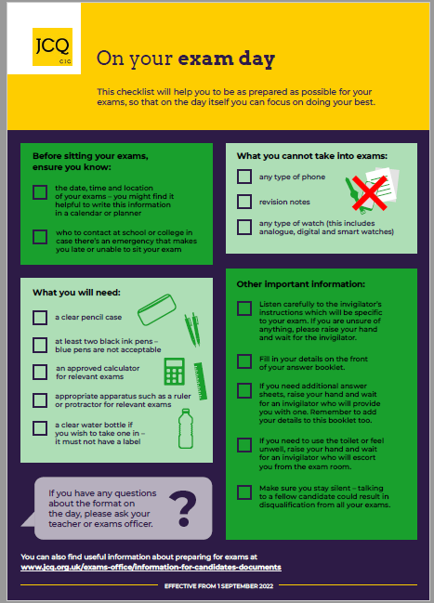

**JCQ - Exam Room Posters**

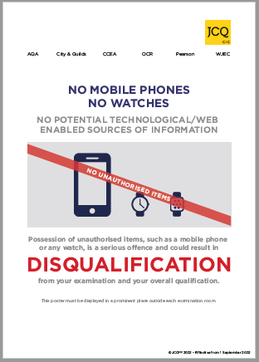

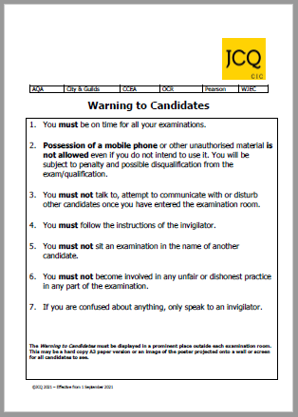

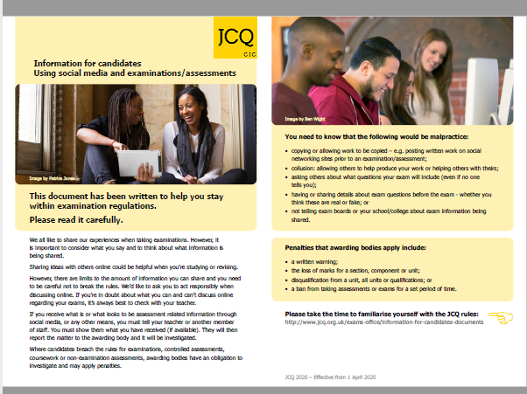

**Calculator Rules**

